DAY 12: EVENING ASSESSMENT

1. What is the purpose of the <form> tag in HTML?

The <form> tag is used to create an HTML form for user input. It wraps input elements like text fields, radio buttons, checkboxes, etc., and allows data to be submitted.

2. Which attribute is used in the <form> tag to specify where to send the form data?

The action attribute is used to specify the URL where the form data should be sent after submission.  
Example: <form action="/submit-data">

3. How do you create a text input field in HTML?

You can create a text input using the <input> tag with type="text"

<input type="text" name="username">

4. What is the use of the type="password" in an <input> tag?

The type="password" creates an input field that hides the characters entered, commonly used for password entry.

<input type="password" name="userpass">

5. How do you create a submit button in a form?

<input type="submit" value="Submit">

6. Which HTML tag is used to group form controls together?

The <fieldset> tag is used to group related elements in a form.

7. Write the HTML code for a form that asks for name and age.

<form action="/submit">

<label for="name">Name:</label>

<input type="text" id="name" name="name"><br><br>

<label for="age">Age:</label>

<input type="number" id="age" name="age"><br><br>

<input type="submit" value="Submit">

</form>

8. What is the purpose of the <header> tag?

The <header> tag is used to define a header section for a document or a section. It often contains the site logo, navigation links, or page title.

9. What is the purpose of the <footer> tag?

The <footer> tag defines the footer section of a page or section. It commonly includes contact info, copyright, links, or credits.

10. Can we use <header> and <footer> multiple times on the same page? Why?

Yes, you can use them multiple times on a page. They can be used within different sections or articles to define headers/footers specific to those parts.

11. Write an example of a basic webpage that includes <header> and <footer> sections.

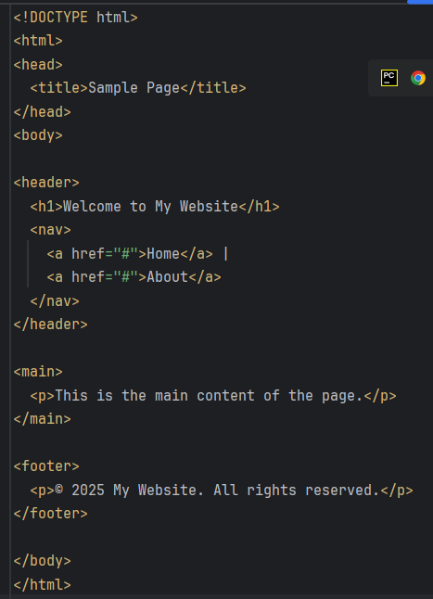

12. What is the HTML tag used to create a dropdown list?

The <select> and <option> tag is used to create a dropdown list.

13. How do you add options to a dropdown list in HTML?

<select>

<option>Option 1</option>

<option>Option 2</option>

</select>

14. What does the selected attribute do in a <select> element?

The selected attribute pre-selects an option when the page loads.

<option selected>Option 1</option>

15. How do you allow users to select more than one option in a dropdown?

Add the multiple attribute to the <select> tag

<select multiple>

<option>Option A</option>

<option>Option B</option>

</select>

16. How do you group related options inside a dropdown?

Use the <optgroup> tag with a label

<select>

<optgroup label="Fruits">

<option>Apple</option>

<option>Banana</option>

</optgroup>

</select>

17. Write an example of a dropdown list with 3 fruits.

<select name="fruits">

<option>Apple</option>

<option>Banana</option>

<option>Mango</option>

</select>

18. What does the disabled attribute do in an <input> or <select> tag?

It makes the element unselectable or uneditable and prevents user interaction.

19. How do you make a dropdown menu where the first option is disabled?

<select>

<option disabled selected>Select a fruit</option>

<option>Apple</option>

<option>Mango</option>

</select>

20. Write an input field for email that is disabled and has a default value.

<input type="email" value="shreyagore@something.com" disabled>